Lab 19

Configuring group policy Processing

This lab contains the following exercises and activities:

|  |  |
| --- | --- |
| Exercise 19.1 | Configuring Processing and Precedence of GPOs |
| Exercise 19.2 | Configuring Blocking Inheritance and Enforced Policies |
| Exercise 19.3 | Configuring Security Filtering and WMI Filtering |
| Exercise 19.4 | Configuring Loopback Processing |
| Lab Challenge | Using Group Policy Results Wizard |

BEFORE YOU BEGIN

The lab environment consists of student workstations connected to a local area network, along with a server that functions as the domain controller for a domain called *contoso.com*. The computers required for this lab are listed in Table 19-1.

Table 19-1

Computers Required for Lab 19

|  |  |  |
| --- | --- | --- |
| Computer | Operating System | Computer Name |
| Server (VM 1) | Windows Server 2012 | RWDC01 |

In addition to the computers, you also require the software listed in Table19-2 to complete Lab 19.

Table 19-2

Software Required for Lab 19

|  |  |
| --- | --- |
| Software | Location |
| Lab 19 student worksheet | Lab19_worksheet.rtf (provided by instructor) |

Working with Lab Worksheets

Each lab in this manual requires that you answer questions, shoot screen shots, and perform other activities that you will document in a worksheet named for the lab, such as Lab19_worksheet.rtf. You will find these worksheets on the book companion site. It is recommended that you use a USB flash drive to store your worksheets, so you can submit them to your instructor for review. As you perform the exercises in each lab, open the appropriate worksheet file using WordPad, fill in the required information, and save the file to your flash drive.

After completing this lab, you will be able to:

* Configure the processing order and precedence of GPOs
* Configure blocking of inheritance and enforced policies
* Configure security and WMI filtering
* Configure loopback processing

Estimated lab time: 60 minutes

|  |  |
| --- | --- |
| Exercise 19.1 | Configuring Processing and Precedence of GPOs |
| Overview | During this exercise, you create multiple GPOs and look at overall precedence of the GPOs. |
| Completion time | 20 minutes |

**Mindset Question: During this lab, you learn how group policies are applied, and how to modify the order in which they are applied. How are group policies processed, and what is the precedence of each GPO?**

**1.** Log in to RWDC01 as the **Contoso\administrator** user account with the password of **Password01**. The Server Manager console opens.

**2.** Using Server Manager, click Tools > Active Directory Users and Computers. The Active Directory Users and Computers console opens.

**3.** Under the Sales OU, create an East OU and a West OU.

**4.** Using Server Manager, click Tools > Group Policy Management. The Group Policy Management console opens.

**5.** Navigate to and click the Sales OU.

**6.** Right-click the Sales OU and click *Create a GPO in this domain, and Link it here*. When the New GPO dialog box opens, type in **GPO1**. Click OK.

**7.** Create a GPO called **GPO2** for West OU.

**8.** Create a GPO called **GPO3** for the East OU.

**9.** Create a GPO called **GPO4** for the contoso.com domain.

**10.** Create a GPO called **GPO5** for the Sales OU.

**11.** Create a GPO called **GPO6** for the East OU.

**12.** Create a GPO called **GPO7** for the East OU.

**13.** ClickEast OU, as shown in Figure 19-1. In the East pane, click Group Policy Inheritance.

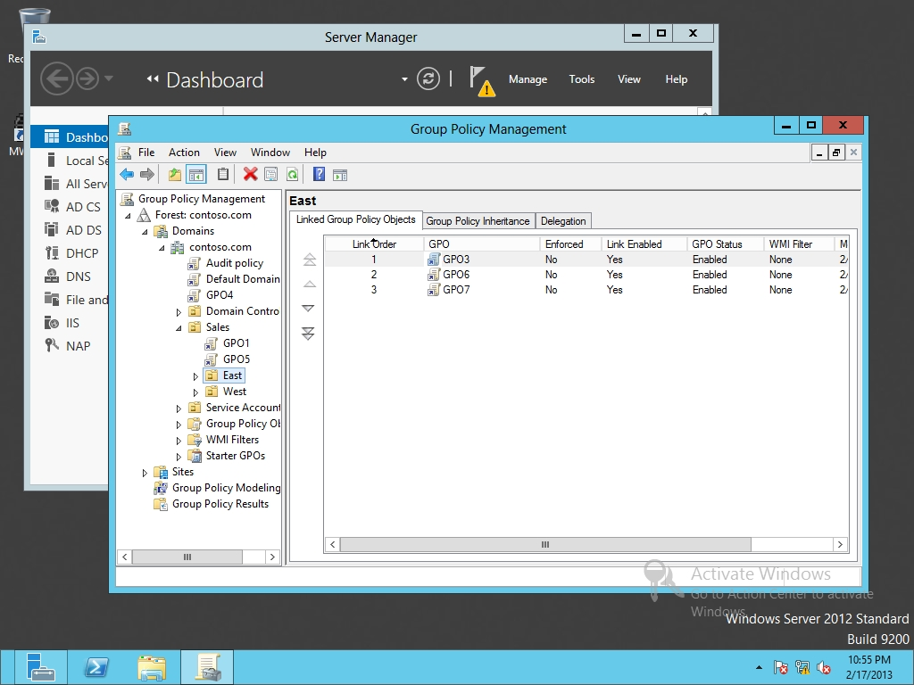

Figure 19-1

Viewing GPOs linked to a OU

|  |  |
| --- | --- |
| Question 1 | What is the order of GPOs that are being applied? |

**14.** For the East OU, click Linked Group Policy Objects.

|  |  |
| --- | --- |
| Question 2 | What are the three GPOs linked to the East OU? List them in order. |

**15.** Click GPO7. Then click the double up arrow.

|  |  |
| --- | --- |
| Question 3 | What are the three GPOs linked to the East OU? List them in order. |

**16.** Click the Group Policy Inheritance tab.

|  |  |
| --- | --- |
| Question 4 | What is the order of GPOs that are being applied? |

**17.** Take a screen shot of the Group Policy Management window by pressing Alt+Prt Scr and then paste it into your Lab19_worksheet file in the page provided by pressing Ctrl+V.

**18.** Keep the Group Policy Management console open for the next exercise.

End of exercise. You can leave the windows open for the next exercise.

|  |  |  |
| --- | --- | --- |
| Exercise 19.2 | | Configuring Blocking Inheritance and Enforced Policies |
| Overview | During this exercise, you modify the order and precedence of GPOs by blocking inheritance and using enforced policies. | |
| Completion time | 10 minutes | |

**Mindset Question: From time to time, you want control how the settings are applied to a container. Therefore explain how you can stop group policies from inheriting to lower containers and how to ensure that group policies that are processed later will overwrite the specified settings in the earlier GPO?**

**1.** On RWDC01, with Group Policy Management, navigate to and click the EastOU.

**2.** Right-click the East OU and select Block Inheritance. An exclamation point inside a blue circle appears for the container as shown in Figure 19-2.

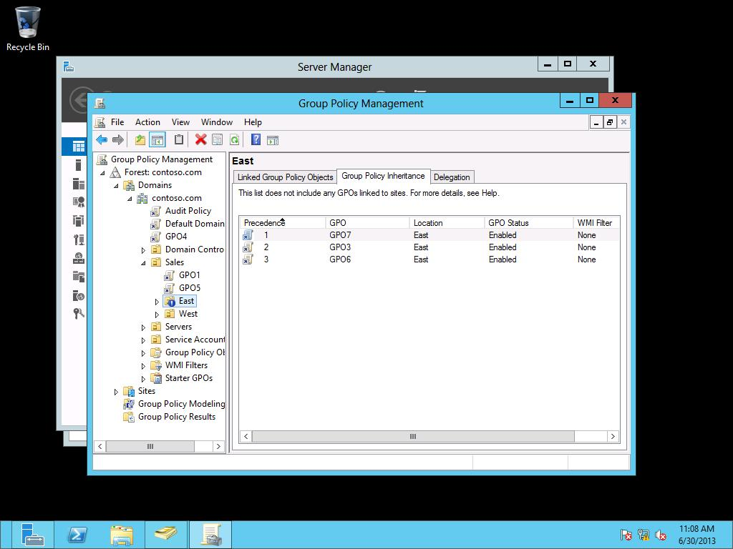

Figure 19-2

Viewing the East OU with block inheritance

**3.** Click the Group Policy Inheritance tab.

|  |  |
| --- | --- |
| Question 5 | What is the order of GPOs that are being applied to the East OU? |

**4.** Right-click GPO4, and click Enforced.

|  |  |
| --- | --- |
| Question 6 | What is the order of GPOs that are being applied to the East OU? Note: You might need to press F5 key to refresh the screen. |

**5.** Take a screen shot of the Group Policy Management window by pressing Alt+Prt Scr and then paste it into your Lab19_worksheet file in the page provided by pressing Ctrl+V.

**6.** Leave the Group Policy Management console open for the next exercise.

End of exercise. You can leave the windows open for the next exercise.

|  |  |
| --- | --- |
| Exercise 19.3 | Configuring Security Filtering and WMI Filtering |
| Overview | During this exercise, you fine-tune the processing of GPOs by using security filtering and WMI filtering. |
| Completion time | 10 minutes |

**Mindset Question: You assign a GPO to an Organizational unit. How can you specify that the GPO will run on some systems, but not others?**

**1.** On RWDC01, using Server Manager, open the Tools menu, and click Active Directory Users and Computers.

**2.** In Active Directory Users and Computers console, under Contoso.com, right-click the Sales OU, click New, and click User.

**3.** When the New Object – User dialog box opens, enter the following information and click Next:

First name: **John**

Last name: **Smith**

User logon name: **JSmith**

**4.** In the Password and Confirm password text boxes, type **Password01**.

**5.** Click the Password never expires. When a warning appears, click OK. Click Next.

**6.** When the wizard is complete, click Finish.

**7.** Using Group Policy Management, click GPO5 that is assigned to the Sales OU. If needed, click OK on the message box that appears.

**8.** Click the Delegation tab and click Advanced. The GPO Security Settings dialog box opens as shown in Figure 19-3.

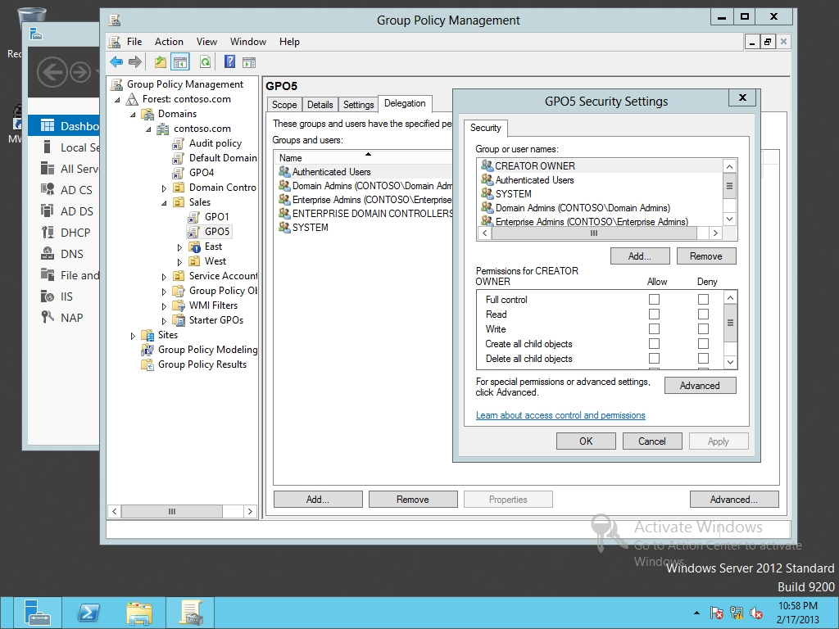

Figure 19-3

Viewing a GPO security settings

|  |  |
| --- | --- |
| Question 7 | What permissions are needed for a GPO to apply to a user? |

**9.** Click the Add button. The Select users, Computers, Service Accounts, or Groups dialog box opens.

**10.** In the text box, type **John Smith** and press the Enterkey.

**11.** With John Smith highlighted, assign the Deny Apply group policy and click OK. When it states that Deny entries take precedence and asks whether you want to continue, click Yes.

**12.** In the left pane, navigate to and click the WMI filters.

**13.** Right-click the WMI Filters node and click New. The New WMI Filter dialog box opens as shown in Figure 19-4.

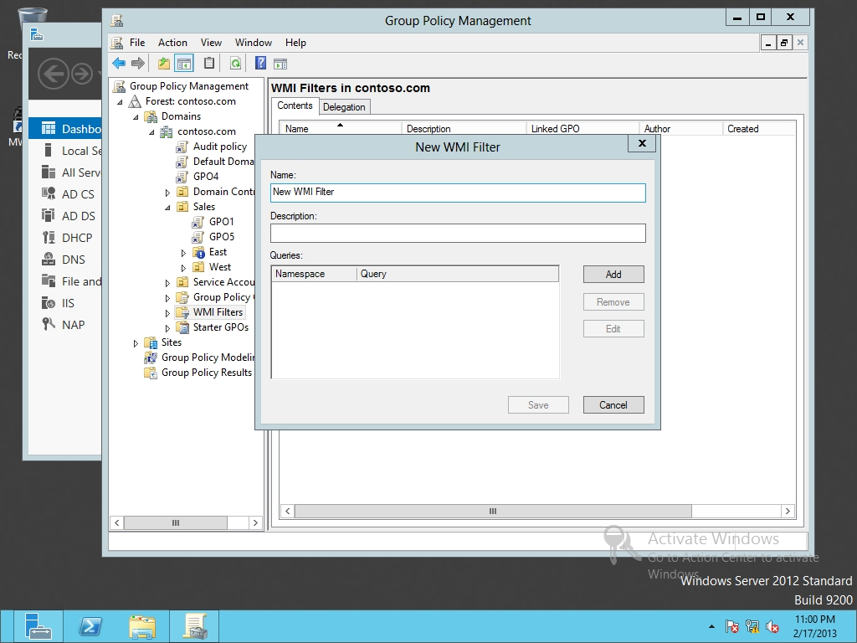

Figure 19-4

Creating a new WMI filter

**14.** In the Name and Description fields, type **WMIFilter1** in the Name text box.

**15.** In the Queries section, click Add. The WMI Query dialog box opens.

**16.** In the Query text box, type the following and click OK:

**Select * from Win32_Processor where AddressWidth ='32'**

**17.** Click Save to create the WMI filter.

**18.** Click GPO5. If a message box appears, click OK. Click the Scope tab.

**19.** Under WMI Filtering, select WMIFilter1. Click Yes to confirm your changes.

**20.** Leave the Group Policy Management console open for the next exercise.

End of exercise. You can leave the windows open for the next exercise.

|  |  |
| --- | --- |
| Exercise 19.4 | Configuring Loopback Processing |
| Overview | During this exercise, you have the computer settings overwrite the user settings when applying GPO settings. |
| Completion time | 5 minutes |

**Mindset Question: You are responsible for establishing a multiple kiosk computer that will be used within the front lobby of your company. You want to ensure that the configuration of the computer is the same regardless of who logs on. How can you do it?**

**1.** On RWDC01, with Group Policy Management, click GPO1. If a message box appears, click OK.

**2.** Right-click GPO1 and click Edit. The Group Policy Management Editor opens.

**3.** Navigate to and double-click Computer Configuration\Policies\Administrative Templates\System\Group Policy\Configure user Group Policy Loopback processing mode.

**4.** When the Configure user Group Policy loopback processing mode dialog opens, click Enabled.

|  |  |
| --- | --- |
| Question 8 | What is the difference between Replace and Merge? |

**5.** Change the mode to Merge and click OK.

**6.** Close Group Policy Management Editor.

Lab REview Questions

|  |  |
| --- | --- |
| **Completion time** | **5 minutes** |

**1.** In Exercise 19.1, which policy has the highest precedence?

**2.** In Exercise 19.2, how do you make sure that a GPO that is assigned at the domain level is not overwritten by GPOs at a lower level?

**3.** In Exercise 19.3, where do you define the security filtering of GPOs?

**4.** In Exercise 19.4, how do you ensure computer settings are applied after user settings?

|  |  |
| --- | --- |
| Lab Challenge | Using Group Policy Results Wizard |
| Overview | To complete this challenge, you will demonstrate how to use the Group Policy Results Wizard to view current GPO settings being applied to a user. |
| Completion time | 10 minutes |

Over the last few months, you and your team have created and applied over 30 GPOs. However, you are getting a little bit confused on which GPOs are being applied. What can you do to determine which GPOs are being applied?

Write out the steps you performed to complete the challenge.

End of lab. You can log off or start a different lab. If you want to restart this lab, you’ll need to click the End Lab button in order for the lab to be reset.